***CONSUMING API IN .NET CORE***

***Using Asp.Net Core Web Api in .Net Core MVC***

## ***Select Asp.Net Core (MVC):***

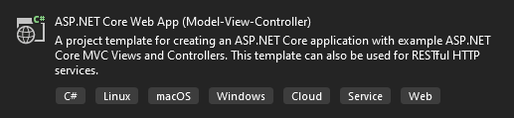

## ***Install Following Packages:***

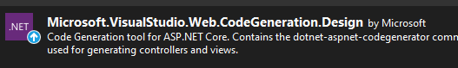

## ***Create student Model :***

public class Student

{

public int Id { get; set; }

public string? Name { get; set; }

public string? Gender { get; set; }

public int? Age { get; set; }

public int? Standard { get; set; }

public string? Fathername { get; set; }

}

## ***Add StudentController***

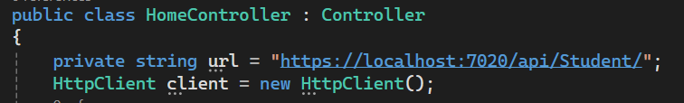

## ***To Fetch All Student From Api***

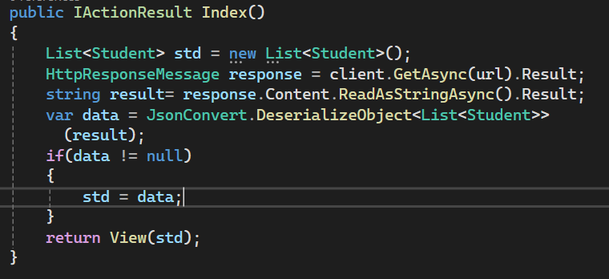

## ***To Fetch Selected Student From Api***

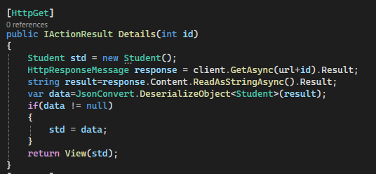

## ***To post Student data to Api***

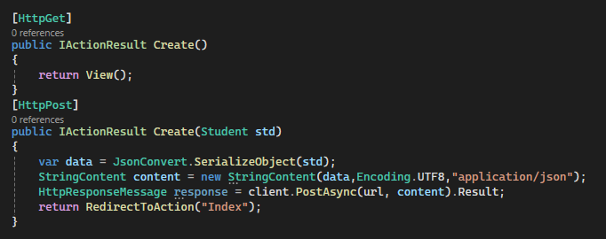

## ***To put(Update) Student data to Api***

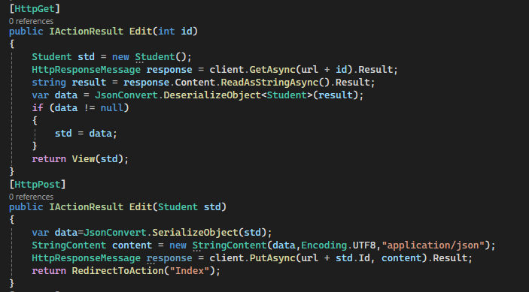

## ***To Delete Student data to Api***

